|  |  |  |
| --- | --- | --- |
|  |  | **School Newsletter 11th March 2024** |
| **Ltyentye Apurte Catholic School**  Church Street, Santa Teresa, PMB 221, Via Alice Springs, NT, 0872.  Telephone: (08) 8956 0937 email: robert.dreise@nt.catholic.edu.au |

Dear Families,

**Let us pray during the season of lent:**

Loving God,

Help us to work together

To share what we have

So that everyone has what they need.

Help us build a better world

Where each of us can become the best person, we can be.

Amen

**News**

|  |  |
| --- | --- |
|  | **Staffing**  A warm welcome to David Solomon. We are very fortunate to have a very experienced teacher join our team. We hope David’s experience at LACS is both fulfilling and rewarding. |
| [This Photo](https://fdroog.wordpress.com/category/socialemedia) by Unknown Author is licensed under [CC BY-SA-NC](https://creativecommons.org/licenses/by-nc-sa/3.0/) | **NAPLAN**  NAPLAN Wednesday Years 3,5,7 & 9. Writing & Reading  Thursday Years 3,5,7 & 9. Conventions of Language / Numeracy |
|  | School Wide Positive Behaviour Support Program. We ask that parents and carers support |
| Attendance Matters-Everyday Counts | Bonnie Brennan Elementary | Every day countsParents / Carers.  YOU have a legal and moral responsibility to make sure your  child comes to school everyday. |
|  | .  Community Members are invited to our upcoming Holy Week Passion Play. Thursday 28th March 9am.  [This Photo](https://religious.najith.com/during-this-holy-week/) by Unknown Author is licensed under [CC BY](https://creativecommons.org/licenses/by/3.0/) |
|  | MacDonnelll Regional Council has organised a Healthy Communities Event this Thursday 14th March. All community members are welcome to come along and learn about how we can live a fun and healthy lifestyle. |

In this week’s newsletter, Ltyentye Apurte Catholic School pays respect to recently departed Kwementyaye Wallace. May the Spirit of Kathleen Wallace, and all deceased members of the Santa Teresa community, dwell in the hearts of those in mourning. We pray to the Lord.

**Kwementyaye Wallace**

Kwementyaye Wallace was born on 1 July 1948 near Ltyentye Apurte, a remote area of Central Australia. She was a senior Eastern Arrernte speaker. Her family kept her away from stations and missions to prevent her removal under the Aboriginals Ordinance 1918. When she was 13, her family was forced to move to Santa Teresa Mission. This move was caused by severe drought and the interruption of traditional hunting and food gathering by encroaching station activities. Kwementyaye Wallace passed away on 28 February 2024. [Source: adapted from Wikipedia ]

**In Her Own Words…..**

"I thought about how my ancestors taught me, their beliefs, and I remembered how they celebrated God in their own way,"

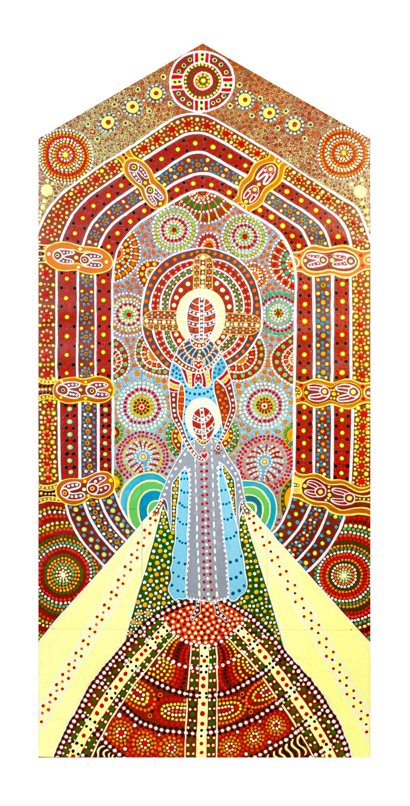"When I went to Santa Teresa, nuns taught me the Bible. When I came to Santa Teresa I couldn't speak English — I learned it there," she said.

"[Catholicism and my family's traditional beliefs] are similar — it wasn't hard for me.

"My grandfather's ancestors gave him a dream of three circles — grandfather, father and totem spirit — like the Holy Trinity."

That design sits in the window's apex.

The church's Aboriginal congregation chose Ms Wallace to design the window.

Her design shows Mary and Jesus as Aboriginal people, and she painted their bodies with designs used in traditional Arrernte celebrations.

"I first started painting on bodies for celebration when I was six. It has been really different learning to paint on canvas."

The mural's eight distinct oval designs represent Arrernte skin names.

Ms Wallace said the painting's dots represented "everything in the world — we are all connected".

Source: ABC News 14/10/2019 https://www.abc.net.au/news/2019-10-14/stained-glass-church-window-blends-catholic-and-aboriginal-faith/11597146

Title: ‘Urtakwerte Atywerrenge Anthurre’ (Very Sacred Heart)

Artist: Kathleen Kemarre Wallace

Location: Our Lady of the Sacred Heart Catholic Church, Alice Springs, NT.

***We listen…***

The Milky Way is like a big creek bed, where the sisters go to sit and look for yams to dig, and to dance their dances. You can see they’re still dancing because the stars are twinkling. To this day, my people look to the Seven Sisters and watch them dance, and that way we know when winter is coming, because the Milky Way turns downwards in the sky. Looking for summer, the people a ask, “where are the Seven Sisters, where are they dancing tonight?” They are a really good sign for our people.

Extract from the story *Seven Sisters* by Kathleen Wallace in *Listen Deeply: Let these Stories In (2009) p205*

*Artwork: Seven Sisters in the Stars, 2005, by Kathleen Wallace, acrylic on canvas, 30x56 cm p105*

Thank you to Susan Poetsch, Teresa Alice and Ailsa Purdon from Batchelor College who were in the community and school to present a trial of Certificate III for First Language speakers.  With support from Bernice and CR it was a real success. From Tuesday to Friday, 6 Arrernte ATs attended the first workshop of the course to improve the understanding of written Arrernte and the sound system developed to describe it.  It will continue with one week workshop per term with an hour of supported study to complete each unit.  This course is essential to make our Language and Culture program strong for our children and it gives them a pathway to look at a future in teaching, translation, ranger work or liaison in health and education.  Ask any of the students if they enjoyed it!

